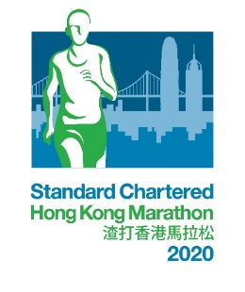

Most Supportive Group Award
Entry Form
Criteria
- Each company / organisation must register with a minimum of 200 members.
- Participants MUST be registered members / permanent of part-time staff from SAME company / organisation.

*** Entry Deadline – 4 December 2019 (Wednesday) ***
Benefits for Joining the Most Supportive Group Award
- Dedicated Customer Service Hotline
- Group collection for Runners’ Packs at Marathon Carnival 2020
- 5 Cheering Passes (Top 3 groups with highest number of registered participants ONLY)
Application Procedures
- All participants must have successfully registered for the Standard Chartered Hong Kong Marathon through the online registration system beforehand.
- Fill in the participant list (in excel format) with names and registration ID of all members.
- Complete this Entry Form.
- Send the above information to Miss LAM of the Marathon Registration and Runners’ Communications Office via email at alam@actionhouseintl.com by 4 December 2019.

To know more about the Award, please contact Marathon Registration and Runner’s Communication Office at 3758 2935 during office hours.

Remarks:
- Entry Fee is non-refundable and non-transferable once application is accepted.
- The Organiser reserves the right not to entertain late submission.
- Participants who are one of the members or staff of the following companies / organisations, are not allowed to represent any other companies / organisations to compete for the Awards:
- Standard Chartered Bank
- Hong Kong Amateur Athletic Association Limited and its Affiliated Member Clubs
- Sponsors and Supporting Organisations of the Standard Chartered Hong Kong Marathon 2020

Most Supportive Group Award
Entry Form
Group Information
Company / Organisation (Chi.):
Company / Organisation (Eng.):
Contact Person (Chi.): |  |  |  | Contact Person (Eng.):
Email:
Phone no. (Daytime): |  |  |  | Fax No.:
Runners’ Pack Collection
The Standard Chartered Hong Kong Marathon Carnival will be held on 5 – 8 February 2020 (Wednesday to Saturday) at Victoria Park, Hong Kong.

Please choose one of the following Runners’ Packs Group Collection Service Option. (Note: The company / organisation shall choose either Group Collection or Individual Pickup for the entire group. Mixture of both will not be entertained)

☐ | A group representative will collect the Runners’ Pack for all members at the Marathon Carnival 2020; OR
☐ | Team members will collect their own Runners’ Pack individually at the Marathon Carnival 2020, in person or authorise a representative, by presenting the Runner’s Pack Collection Letters with their QR-code
Participants List
Please submit a list of all registered members using the standard form attached.

The completed form and the participant list should be sent to Miss Lam of Marathon Registration and Runner’s Communication Office via email alam@actionhouseintl.com by 4 December 2019.
Name & Signature of Authorised Person
(with Company/Organisation Chop):
Date:

